Project Design Phase-II
Data Flow Diagram & User Stories

Date | 13 October 2026
Team ID
Project Name | Metro Ticket Generating System in ServiceNow
Maximum Marks | 4 Marks

Data Flow Diagrams:
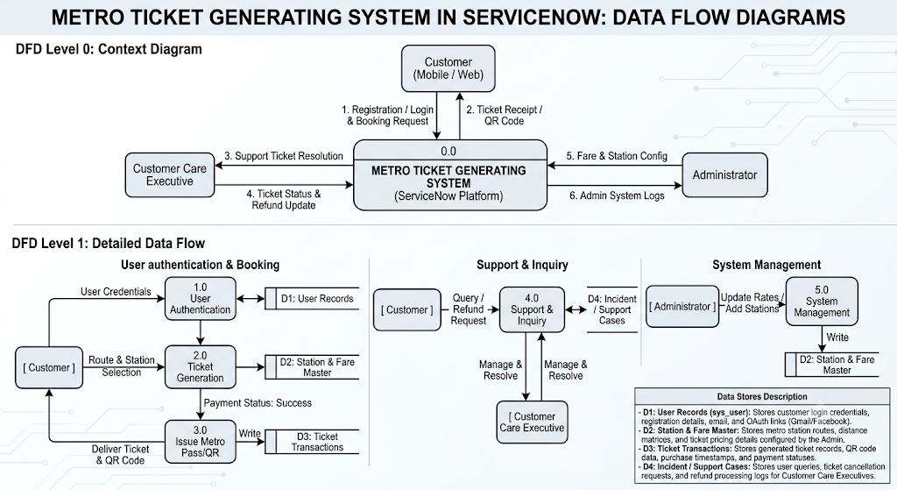
User Stories
Use the below template to list all the user stories for the product.
User Type | Functional Requirement (Epic) | User Story Number | User Story / Task | Acceptance criteria | Priority | Release
Customer (Mobile user) | Registration | USN-1 | As a user, I can register for the application by entering my email, password, and confirming my password. | I can access my account / dashboard upon successful registration. | High | Sprint-1
Customer (Mobile User) | Registration | USN-2 | As a user, I will receive confirmation email once I have registered for the application | I can receive a confirmation email and click to confirm my account. | High | Sprint-1
Customer (Mobile User) | Registration | USN-3 | As a user, I can register for the application through Facebook | I can register & access the dashboard with Facebook Login | Low | Sprint-2
Customer (Mobile User) | Registration | USN-4 | As a user, I can register for the application through Gmail | I can register and access the dashboard using Gmail OAuth. | Medium | Sprint-1
Customer (Mobile User) | Login | USN-5 | As a user, I can log into the application by entering email & password | I can successfully log in and navigate to the home dashboard. | High | Sprint-1
Customer (Web / Mobile) | Ticket Generation | USN-6 | As a user, I can select origin and destination stations to generate a metro ticket and complete the payment. | Ticket QR code/details are generated and stored in my account history. | High | Sprint-1
Administrator | System Managemen | USN-7 | As an admin, I can update fare details and station lists within ServiceNow. | Fare modifications reflect immediately across the ticketing portal. | High | Sprint-2

